📘 碳纤维复合材料回收粉碎系统解决方案
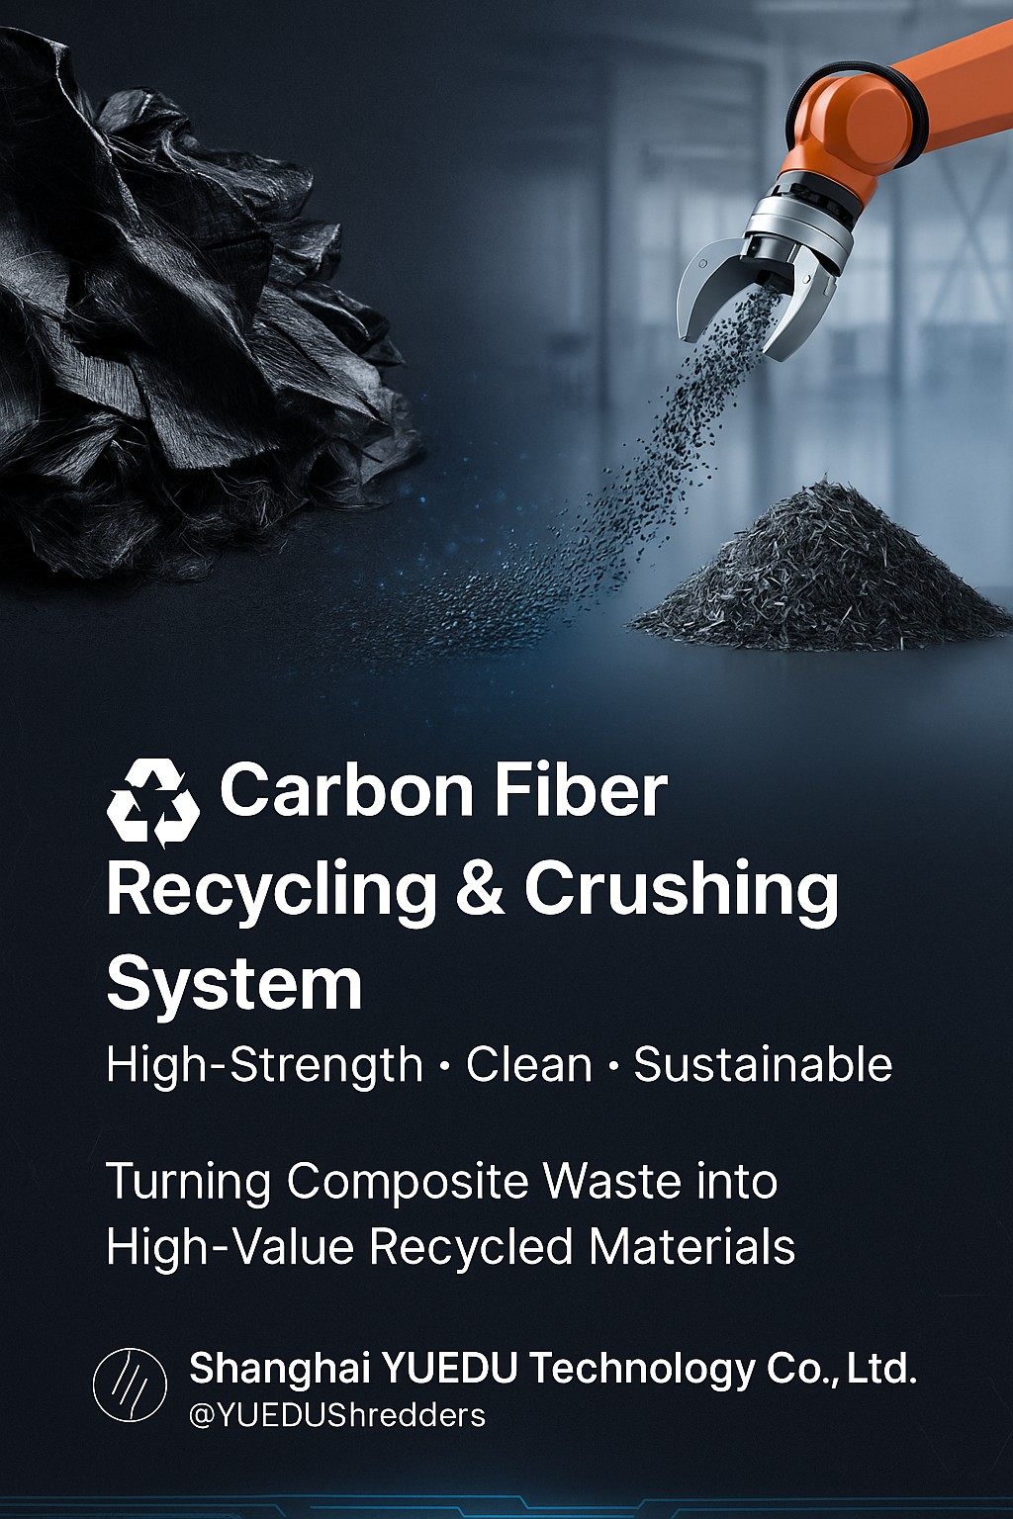

适用客户行业：
碳纤维复合材料厂、风电叶片制造、汽车零部件、无人机制造、改性塑料厂

一、行业背景
碳纤维复合材料因其轻量化、高强度和耐腐蚀特性，被广泛应用于航空航天、新能源汽车、风电、轨道交通及高端制造领域。
但在生产及报废过程中，大量边角料、预浸布废料和报废件难以有效回收。传统粉碎设备普遍存在导电粉尘外溢、纤维断裂严重、刀具磨损快等问题。
当碳纤维被粉碎至≤2cm后，其再生纤维仍能保留约90%的机械强度与优异的导电性能，可被重新用于汽车、建筑、塑料改性等多个行业，实现60%以上成本节约。
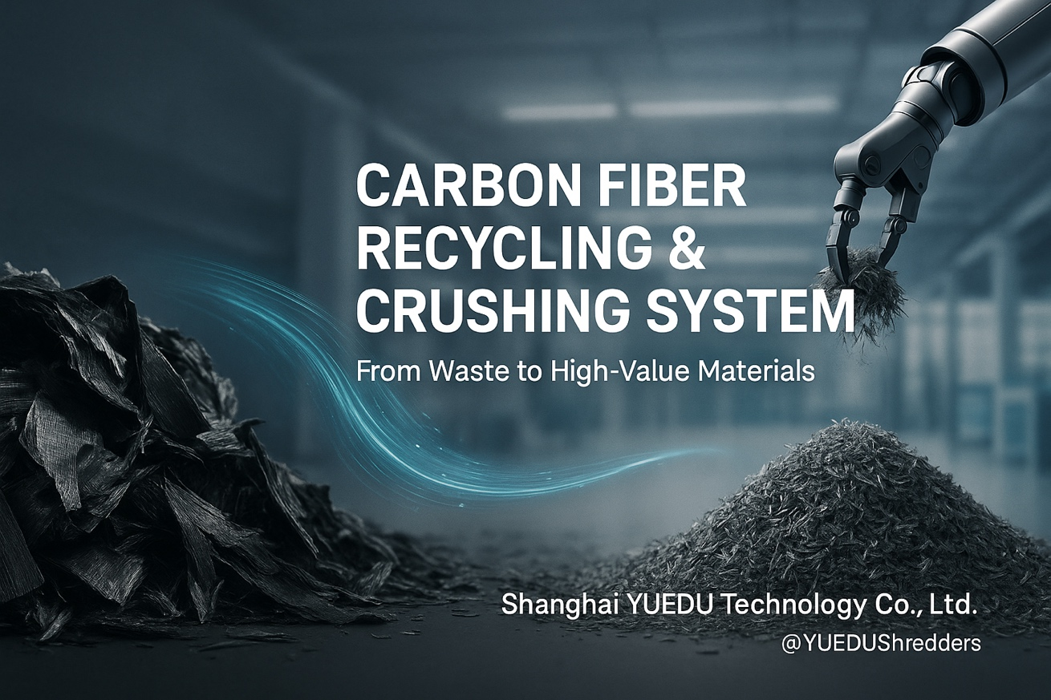

二、客户痛点分析
编号 | 痛点 | 说明
① | 导电碳粉风险 | 碳粉导电，易造成电机短路与环境污染。
② | 粉碎难度大 | 纤维韧性高，普通设备易卡机或损坏刀具。
③ | 粒径难控制 | 常规设备无法稳定控制在10–20mm。
④ | 温升过高 | 热积聚导致碳纤维氧化变脆。
⑤ | 环保问题 | 粉尘外逸，难以达EHS环保标准。

三、越都解决方案
系统名称： YD-FSJ系列碳纤维粉碎回收系统
系统流程：
预碎 → 精碎 → 冷却 → 除尘 → 筛分 → 收集打包
核心特点：
- ⚙️ 双轴预破 + 精密粉碎结构，粒径可控至10–20mm；
- 🧲 防静电除尘 + 密闭罩设计，防止碳粉短路与空气污染；
- 💎 高铬耐磨刀具，适应高强度纤维；
- ❄️ 冷却控温 <25°C，保持纤维完整；
- 🧹 自动分级筛选，确保颗粒一致性；
- 🔧 模块化维护结构，换刀与滤网仅需几分钟。

四、应用领域
应用行业 | 应用方向 | 典型用途
🚗 汽车行业 | Automotive | 注塑结构件、导电PA66复合料
🛩 航空航天 / 无人机 | Aerospace / Drone | 壳体增强、蒙皮内层填充
⚙ 工程塑料改性 | Plastic Modification | 碳纤增强料、PPS/PEEK/PC共混
🏗 建筑 / 土木 | Construction | 混凝土增强、抗裂地坪
🔋 新能源 / 风电 | New Energy | 风机叶片、储氢瓶外层填充

五、成果与价值
✅ 再生碳纤维强度保留率 ≥ 90%
✅ 成本降低 ≥ 60%
✅ 替代部分原生碳纤维应用
✅ 粉尘收集率 ≥ 99%，排放达EHS标准
✅ 可扩展自动上料与智能监控系统

六、适配设备型号
型号 | 用途 | 特点
YD-SSJ 双轴撕碎机 | 初级破碎 | 适用于复材板块、预浸布
YD-FSJSL 强力粉碎机 | 中细粉碎 | 高强刀具 + 冷却系统
YD-SL600 静音冷却机 | 精细整粒 | 低噪音、封闭式结构

七、可选配置
- 金属分离器
- 防爆除尘单元
- 自动称重包装系统
- 智能监控平台

八、越都价值
通过智能粉碎与循环利用技术，
上海越都科技有限公司 帮助客户从“废料处理”迈向“资源再造”，
实现 节能、降本、环保、循环制造 的产业升级。

九、典型案例
客户： LN新能源公司
应用： 风电叶片复合材料回收系统
配置： YD-SSJ + YD-FSJSL + 除尘与筛分系统
结果： 产能500kg/h，粉尘外逸率<1%，连续运行72小时稳定。

📘 Carbon Fiber Recycling & Crushing System Solution
Client Industries:
Carbon composite plants, wind turbine blade manufacturers, automotive component makers, UAV producers, and modified plastics factories.

1. Industry Background
Carbon fiber composites are widely used in aerospace, automotive, wind energy, and high-end manufacturing for their light weight and high strength.
However, recycling scrap prepregs and end-of-life components is challenging. Conventional shredders cause conductive dust, excessive fiber breakage, and tool wear.
After being shredded to ≤2 cm, recycled carbon fibers (rCF) retain around 90% of their strength and electrical conductivity, enabling reuse across multiple sectors with over 60% cost savings compared to virgin fibers.

2. Customer Pain Points
No. | Pain Point | Description
1 | Conductive dust risk | Fine carbon dust may cause short circuits or contamination.
2 | Difficult to shred | High toughness damages blades or causes jamming.
3 | Poor size control | Hard to maintain stable 10–20 mm output.
4 | Heat buildup | High temperature leads to oxidation and brittleness.
5 | Environmental limits | Open systems fail to meet EHS dust standards.

3. YUEDU Solution
System Name: YD-FSJQL Series Carbon Fiber Crushing & Recovery System
System Flow: Pre-shredding → Fine crushing → Cooling → Dust collection → Screening → Bagging
Key Features:
- ⚙️ Dual-shaft pre-crusher + precision shredder for 10–20 mm control
- 🧲 Anti-static sealed housing and dust-proof enclosure
- 💎 High-chromium wear-resistant blades for long life
- ❄️ Temperature control < 25 °C to preserve fiber structure
- 🧹 Automatic screening for uniform particle size
- 🔧 Modular design for fast blade and filter replacement

4. Application Fields
Industry | Field | Typical Use
🚗 Automotive | Vehicle parts | Injection molded components, conductive PA66 compounds
🛩 Aerospace / Drone | Aviation | Structural reinforcement, inner shell filling
⚙ Engineering Plastics | Modification | Carbon-reinforced PPS/PEEK/PC materials
🏗 Construction | Civil | Concrete reinforcement, crack-resistant flooring
🔋 New Energy | Wind & Hydrogen | Blade and tank outer layer reinforcement

5. Results & Benefits
✅ Strength retention ≥ 90%
✅ Material cost reduction ≥ 60%
✅ Partial replacement of virgin carbon fiber
✅ Dust capture efficiency ≥ 99% (EHS compliant)
✅ Optional smart feeding & monitoring system

6. Supported Models
Model | Application | Feature
YD-SSJ Twin-Shaft Shredder | Primary shredding | Ideal for composite sheets & prepregs
YD-FSJQL Heavy-Duty Crusher | Secondary shredding | High-strength blades + cooling system
YD-SL600 Silent Cooler | Fine sizing | Low noise, fully enclosed structure

7. Optional Configurations
- Magnetic separator
- Explosion-proof dust collector
- Automatic weighing & packaging unit
- Smart monitoring platform

8. YUEDU Value
Through intelligent shredding and material recycling technology,
Shanghai YUEDU Technology Co., Ltd. helps clients shift from “waste disposal” to “resource regeneration,”
achieving energy saving, cost reduction, environmental protection, and circular manufacturing.
“From Waste to Wealth — Turning Composite Scrap into New Materials.”

9. Typical Case
Client: LN New Energy Co., Ltd.
Application: Wind turbine composite recycling line
Configuration: YD-SSJ + YD-FSJ + dust & screening unit
Result: Capacity 500 kg/h, dust leakage < 1%, 72-hour stable continuous operation.

🌐 Contact Us
Shanghai YUEDU Technology Co., Ltd.
📞 Contact Us to explore more customized models and tailored shredding solutions that suit your specific needs!
Let us help you find the perfect equipment for your application.
📱 Sales Supervisor: +86 159 0178 2779 (WhatsApp / WeChat / Facebook)
📱 Administrative Supervisor: +86 137 6138 5116
📧 Email: yuedushredders@gmail.com | denghao8410@gmail.com
🌐 Website: www.yuedushredders.com
@YUEDUShredders – Empowering Global Industries with Intelligent Destruction Systems.

